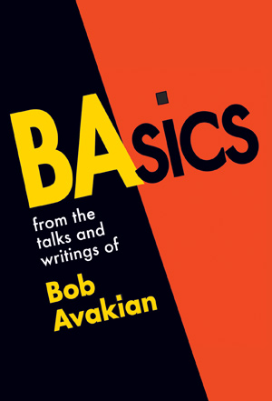
SALES RECEIPT:

Name of Store______________________________
Address___________________________________
Email_____________________________________
Phone_____________
Contact ___________________________________
Date_____________

# of BAsics at $6.00/copy ______ (Cover price $10.00)
Received $_________

Terms: Refund will be given in full for unsold copies if returned in good condition. For restocking or questions please contact:

[Insert Revolution Books, address and phone number and email]

RCP Publications PO Box 3486 Merchandise Mart, Chicago, IL 60654-0486 revcom.us

SALES RECEIPT:

Name of Store______________________________
Address___________________________________
Email_____________________________________
Phone #_____________
Contact ___________________________________
Date_____________

# of BAsics at $6.00/copy ______. (Cover price $10.00)
Received $_________

Terms: Refund will be given in full for unsold copies if returned in good condition. For restocking or questions, please contact:

[Insert Revolution Books, address and phone number)]

RCP Publications PO Box 3486 Merchandise Mart, Chicago, IL 60654-0486 revcom.us

